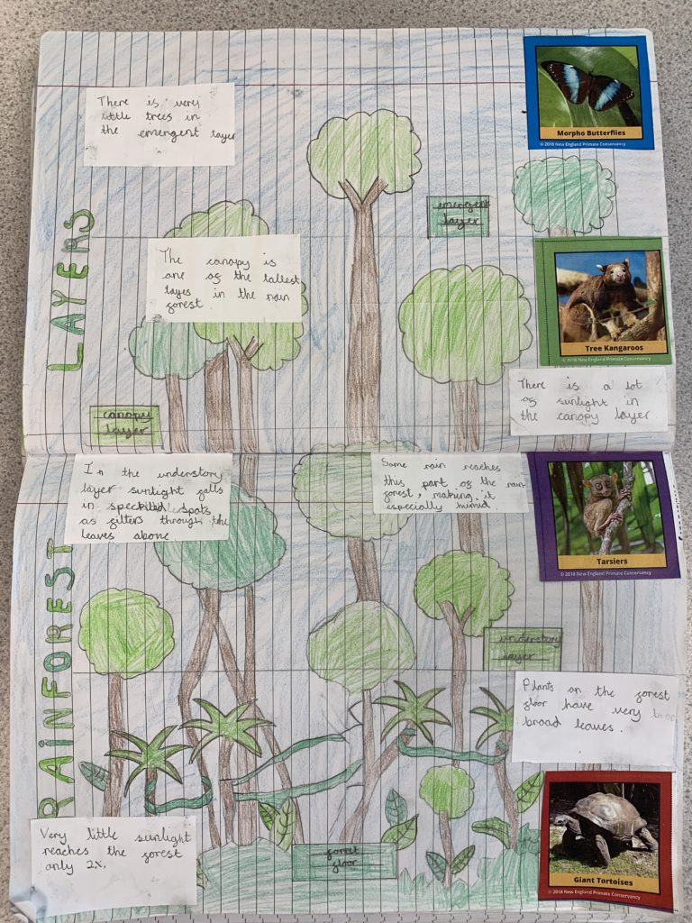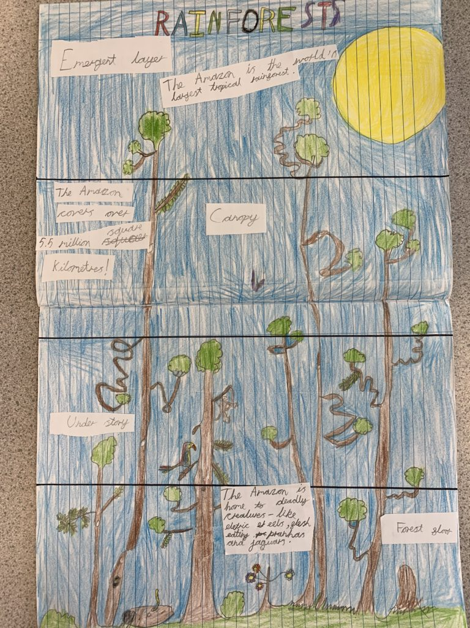

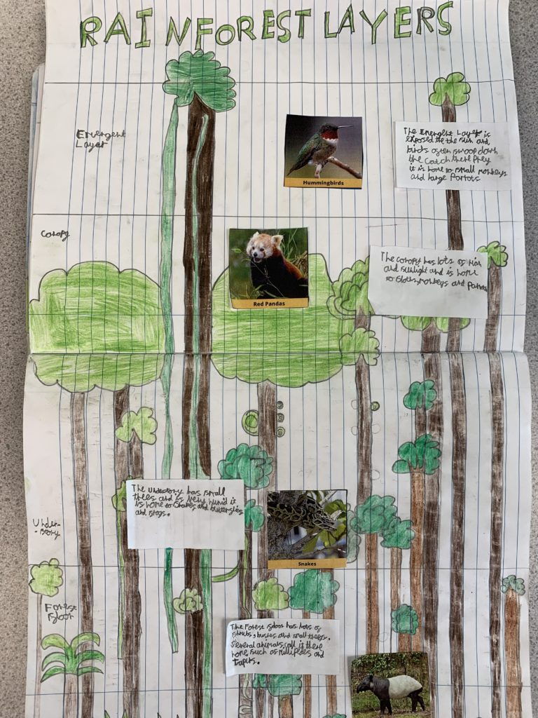
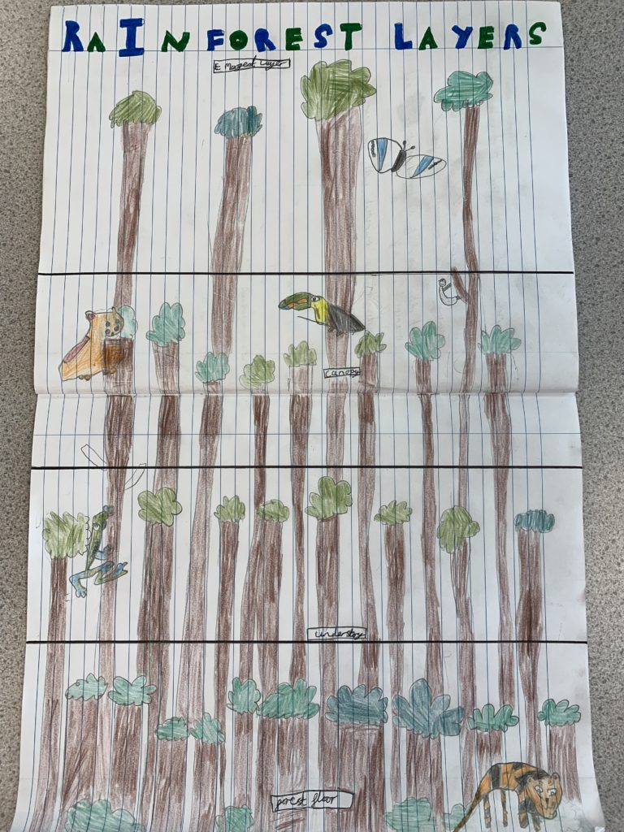

Borrowed from Kingsleigh Primary School blog
Geography - Kingsleigh Primary School

Year 4 have had a fantastic few weeks exploring the rainforests. We have thought about where they can be found and what awesome animals and plants may live there! We started our topic by using our senses and imagined what types of things we might find in the rainforest; we also learnt lots of facts by listening carefully to David Attenborough.
This week, all the children have worked so hard to complete beautiful, factual double-page spreads all about the rainforests. We thought really carefully about the different layers such as the forest floor, the understory, the canopy and the emergent layer. We then thought about these different environments and how different species all need to live in environments which will help them survive. For example, giant tortoises need to stay on the forest floor whereas spider monkeys need to be in the canopy!

